Cyanea Genomics

**Kirstin**  [1:09 PM](https://dunnlab.slack.com/archives/D01CLHU7WNM/p1653066574227829) May 20, 2022

I was finally able to get amplification from many of Lauren's samples. I have yet to submit them for sequencing though. Hopefully the sequences will look good.  
If you go to the linked spreadsheet, I have COI PCR products from all the samples highlighted in green.  
<https://docs.google.com/spreadsheets/d/1jkgs97kRVbv9Y0VFdN0hLAatIEmSBXefERFAjiHBzxQ/edit#gid=0>

June 7, 2022

[**Kirstin**](https://app.slack.com/team/UL0DGTQR4)  [2:31 PM](https://dunnlab.slack.com/archives/D01CLHU7WNM/p1654626675484459)

[@Mary Beth Decker](https://dunnlab.slack.com/team/U996S96N4) I finished editing the Cyanea COI (842 bp) sequences and ran a couple quick analyses on them. The mean within group distance between the 3 fall samples is 0. The mean within group distance between the 4 spring samples is 0.01. The mean between group distance is 0.067. The distance between a C. capatilla and C. lamarckii COI sequence I retrieved from GenBank is also 0.063. :open_mouth:

Below is a pairwise distance matrix and a text file with the methods used to obtain the values.

Cyanea\_COI\_pwdist

,Horse\_Island\_2\_Cyanea\_May\_2022\_1\_{Spring},22\_Cyanea\_sp\_DNA\_voucher\_sep1\_2020\_Dunn\_lab\_2\_1\_{Fall},3\_Oct29\_2021\_Cyanea\_ephyrae\_F2\_DNA\_LM\_1\_{Fall},20\_Sep29\_2020\_Cyanea\_planulae1\_tentacle\_DNA\_LM\_1\_{Fall},10\_May7\_2021\_cyanea5\_1\_{Spring},6\_Apr26\_2021\_cyanea\_sp\_1\_DNA\_LM\_1\_{Spring},JN700937.1\_Cyanea\_capillata\_mitochondrion\_partial\_genome,JX995347.1\_Cyanea\_lamarckii\_isolate\_MT02473\_cytochrome\_c\_oxidase\_subunit\_I\_(COI)\_gene\_partial\_cds\_mitochondrial,GQ120092.1\_Cyanea\_sp.\_BO-2009\_voucher\_Sc11.3.1\_cytochrome\_oxidase\_subunit\_I\_(COI)\_gene\_partial\_cds\_mitochondrial,Horse\_Island\_1\_Cyanea\_May\_2022\_1\_{Spring}

Horse\_Island\_2\_Cyanea\_May\_2022\_1\_{Spring},,,,,,,,,,

22\_Cyanea\_sp\_DNA\_voucher\_sep1\_2020\_Dunn\_lab\_2\_1\_{Fall},0.070,,,,,,,,,

3\_Oct29\_2021\_Cyanea\_ephyrae\_F2\_DNA\_LM\_1\_{Fall},0.067,0.002,,,,,,,,

20\_Sep29\_2020\_Cyanea\_planulae1\_tentacle\_DNA\_LM\_1\_{Fall},0.069,0.004,0.001,,,,,,,

10\_May7\_2021\_cyanea5\_1\_{Spring},0.006,0.070,0.067,0.069,,,,,,

6\_Apr26\_2021\_cyanea\_sp\_1\_DNA\_LM\_1\_{Spring},0.006,0.064,0.061,0.063,0.007,,,,,

JN700937.1\_Cyanea\_capillata\_mitochondrion\_partial\_genome,0.067,0.044,0.041,0.043,0.067,0.061,,,,

JX995347.1\_Cyanea\_lamarckii\_isolate\_MT02473\_cytochrome\_c\_oxidase\_subunit\_I\_(COI)\_gene\_partial\_cds\_mitochondrial,0.074,0.076,0.074,0.074,0.068,0.066,0.063,,,

GQ120092.1\_Cyanea\_sp.\_BO-2009\_voucher\_Sc11.3.1\_cytochrome\_oxidase\_subunit\_I\_(COI)\_gene\_partial\_cds\_mitochondrial,0.066,0.002,0.000,0.001,0.064,0.060,0.041,0.074,,

Horse\_Island\_1\_Cyanea\_May\_2022\_1\_{Spring},0.000,0.070,0.067,0.069,0.006,0.006,0.067,0.074,0.066,

Pairwise\_Distance\_Data.txt

Title: Phylogenetic Analysis

Description

Analysis ====================

Analysis = ====================

Scope = Pairs of taxa

Estimate Variance = ====================

Variance Estimation Method = None

Substitution Model = ====================

Substitutions Type = Nucleotide

Model/Method = Tamura 3-parameter model

Substitutions to Include = d: Transitions + Transversions

Rates and Patterns = ====================

Rates among Sites = Gamma Distributed (G)

Gamma Parameter = 1.00

Pattern among Lineages = Same (Homogeneous)

Data Subset to Use = ====================

Gaps/Missing Data Treatment = Pairwise deletion

[ 1] #Horse\_Island\_2\_Cyanea\_May\_2022\_1\_{Spring}

[ 2] #22\_Cyanea\_sp\_DNA\_voucher\_sep1\_2020\_Dunn\_lab\_2\_1\_{Fall}

[ 3] #3\_Oct29\_2021\_Cyanea\_ephyrae\_F2\_DNA\_LM\_1\_{Fall}

[ 4] #20\_Sep29\_2020\_Cyanea\_planulae1\_tentacle\_DNA\_LM\_1\_{Fall}

[ 5] #10\_May7\_2021\_cyanea5\_1\_{Spring}

[ 6] #6\_Apr26\_2021\_cyanea\_sp\_1\_DNA\_LM\_1\_{Spring}

[ 7] #JN700937.1\_Cyanea\_capillata\_mitochondrion\_partial\_genome

[ 8] #JX995347.1\_Cyanea\_lamarckii\_isolate\_MT02473\_cytochrome\_c\_oxidase\_subunit\_I\_(COI)\_gene\_partial\_cds\_mitochondrial

[ 9] #GQ120092.1\_Cyanea\_sp.\_BO-2009\_voucher\_Sc11.3.1\_cytochrome\_oxidase\_subunit\_I\_(COI)\_gene\_partial\_cds\_mitochondrial

[10] #Horse\_Island\_1\_Cyanea\_May\_2022\_1\_{Spring}

[ 1 2 3 4 5 6 7 8 9 10 ]

[ 1]

[ 2] 0.070

[ 3] 0.067 0.002

[ 4] 0.069 0.004 0.001

[ 5] 0.006 0.070 0.067 0.069

[ 6] 0.006 0.064 0.061 0.063 0.007

[ 7] 0.067 0.044 0.041 0.043 0.067 0.061

[ 8] 0.074 0.076 0.074 0.074 0.068 0.066 0.063

[ 9] 0.066 0.002 0.000 0.001 0.064 0.060 0.041 0.074

[10] 0.000 0.070 0.067 0.069 0.006 0.006 0.067 0.074 0.066

Table. Estimates of Evolutionary Divergence between Sequences

The number of base substitutions per site from between sequences are shown. Analyses were conducted using the Tamura 3-parameter model [1]. The rate variation among sites was modeled with a gamma distribution (shape parameter = 1). This analysis involved 10 nucleotide sequences. All ambiguous positions were removed for each sequence pair (pairwise deletion option). There were a total of 842 positions in the final dataset. Evolutionary analyses were conducted in MEGA11 [2][3]

1. Tamura K. (1992). Estimation of the number of nucleotide substitutions when there are strong transition-transversion and G + C-content biases. Molecular Biology and Evolution 9:678-687.

2. Tamura K., Stecher G., and Kumar S. (2021). MEGA 11: Molecular Evolutionary Genetics Analysis Version 11. Molecular Biology and Evolution https://doi.org/10.1093/molbev/msab120.

3. Stecher G., Tamura K., and Kumar S. (2020). Molecular Evolutionary Genetics Analysis (MEGA) for macOS. Molecular Biology and Evolution 37:1237-1239.

Disclaimer: Although utmost care has been taken to ensure the correctness of the caption, the caption text is provided "as is" without any warranty of any kind. Authors advise the user to carefully check the caption prior to its use for any purpose and report any errors or problems to the authors immediately (www.megasoftware.net). In no event shall the authors and their employers be liable for any damages, including but not limited to special, consequential, or other damages. Authors specifically disclaim all other warranties expressed or implied, including but not limited to the determination of suitability of this caption text for a specific purpose, use, or application.

And a ML tree constructed using the Tamura-3 parameter model with gamma distribution. Bootstrap values were calculated with 100 replicates.

Cyanea\_COI\_MLtree.nwk

(((3\_Oct29\_2021\_Cyanea\_ephyrae\_F2\_DNA\_LM\_1,'GQ120092.1 Cyanea sp. BO-2009 voucher Sc11.3.1 cytochrome oxidase subunit I (COI) gene partial cds mitochondrial',22\_Cyanea\_sp\_DNA\_voucher\_sep1\_2020\_Dunn\_lab\_2\_1,20\_Sep29\_2020\_Cyanea\_planulae1\_tentacle\_DNA\_LM\_1)1.0000,JN700937.1\_Cyanea\_capillata\_mitochondrion\_partial\_genome)0.9900,(((Horse\_Island\_2\_Cyanea\_May\_2022\_1,Horse\_Island\_1\_Cyanea\_May\_2022\_1)1.0000,10\_May7\_2021\_cyanea5\_1)0.9300,6\_Apr26\_2021\_cyanea\_sp\_1\_DNA\_LM\_1)0.9800,'JX995347.1 Cyanea lamarckii isolate MT02473 cytochrome c oxidase subunit I (COI) gene partial cds mitochondrial');

https://files.slack.com/files-pri/T04Q27PCB-F03JR2CHPAQ/screen\_shot\_2022-06-07\_at\_2.42.18\_pm.png

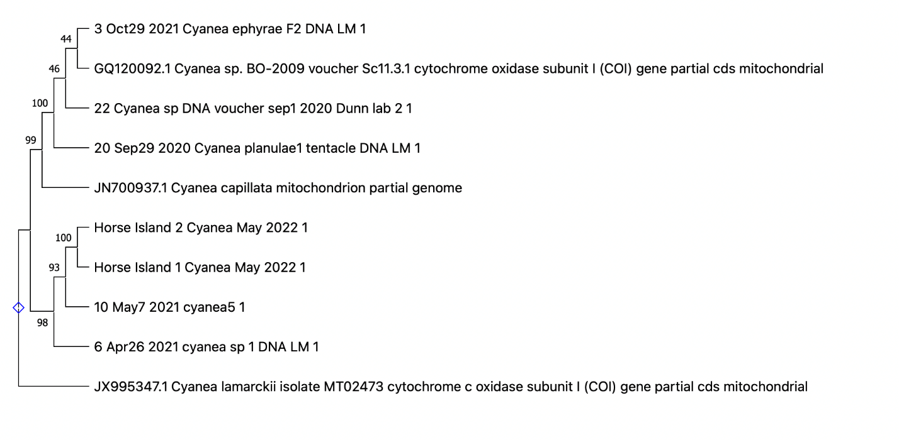

Chat with Kirsten: results to not tell us which species, but tell us that difference in our samples is same degree as between lamarckii and capillata